1. Which are the top three variables in your model which contribute most towards the probability of a lead getting converted?

**Ans** – Following are the top three variables in our model which contribute most towards the probability of a lead getting converted –

* Welingak Website (Lead Source)
* Total Time Spent on Website
* Reference (Lead Source)

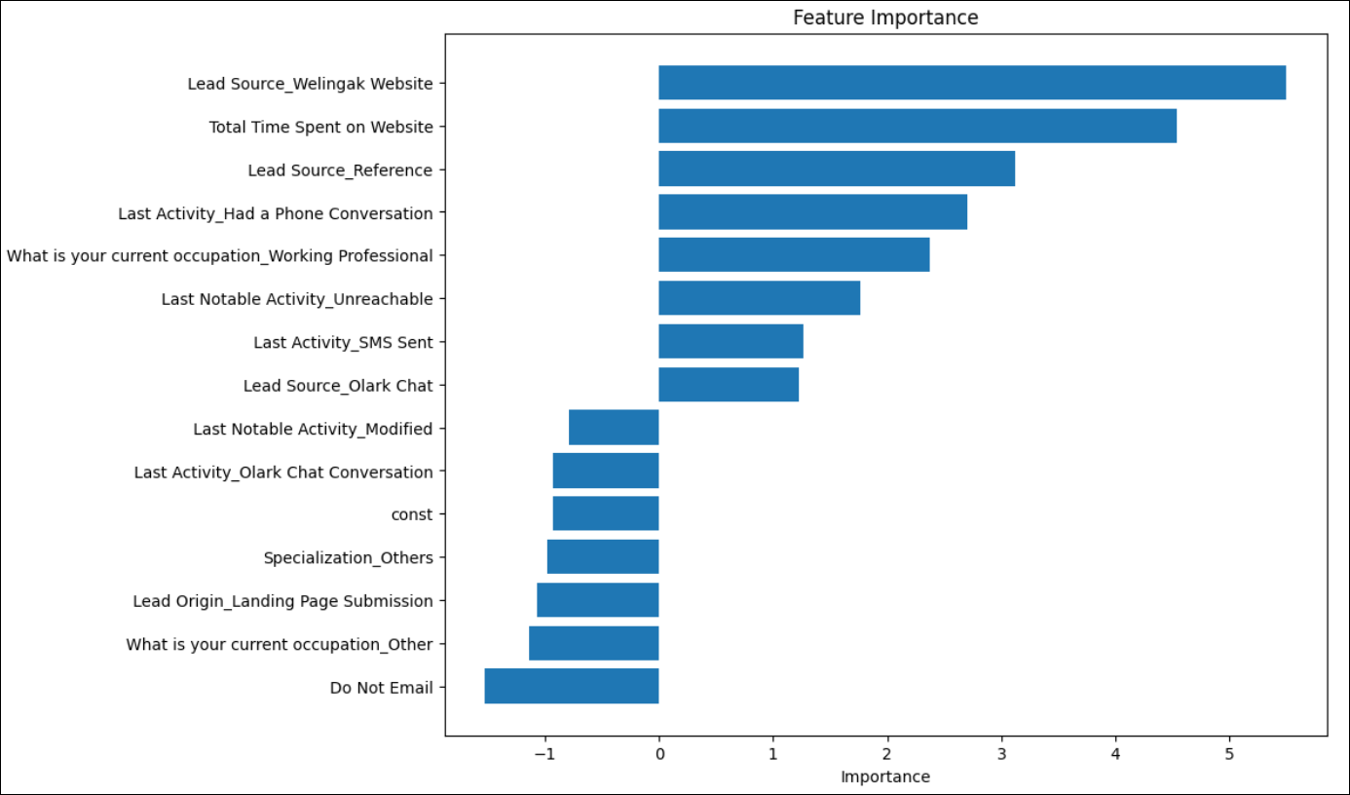

1. What are the top 3 categorical/dummy variables in the model which should be focused the most on in order to increase the probability of lead conversion?

**Ans** – Following are the top 3 categorical/dummy variables in the model which should be focused the most on in order to increase the probability of lead conversion –

* Welingak Website (Lead Source)
* Reference (Lead Source)
* Had a Phone Conversation (Last Activity)

1. X Education has a period of 2 months every year during which they hire some interns. The sales team, in particular, has around 10 interns allotted to them. So during this phase, they wish to make the lead conversion more aggressive. So they want almost all of the potential leads (i.e. the customers who have been predicted as 1 by the model) to be converted and hence, want to make phone calls to as much of such people as possible. Suggest a good strategy they should employ at this stage.

**Ans** – For doing aggressive sales, sales team can contact all lead with Converted_Prob=1 taking cutoff value =0.2 where Sensitivity is high. In that case they will contact more leads which will result more conversion.

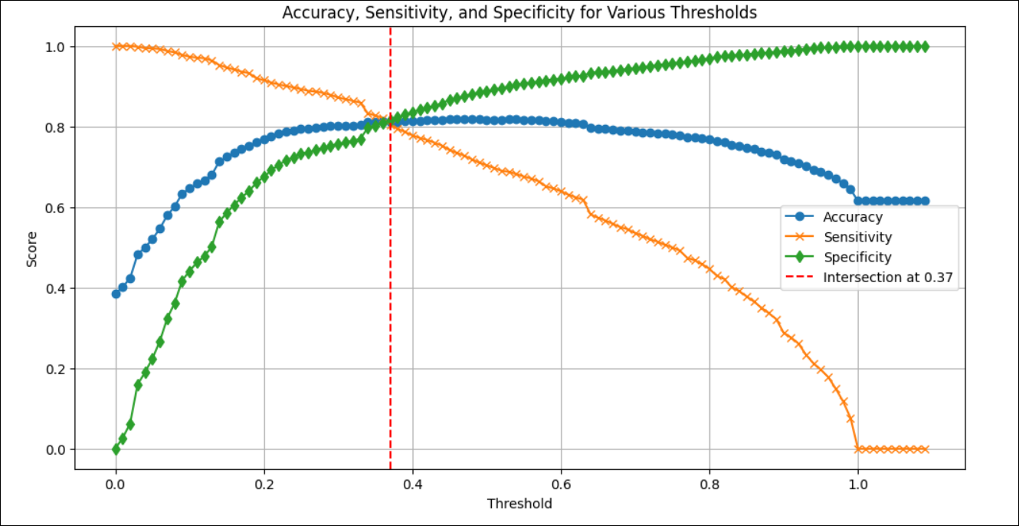

1. Similarly, at times, the company reaches its target for a quarter before the deadline. During this time, the company wants the sales team to focus on some new work as well. So during this time, the company’s aim is to not make phone calls unless it’s extremely necessary, i.e. they want to minimize the rate of useless phone calls. Suggest a strategy they should employ at this stage.

**Ans** – In this case, sales team can contact all lead with Converted_Prob=1 taking cutoff value =0.7 where Specificity is high. So, they will contact less leads which may not be good for conversion. However, no of phone calls will be less and will not cause any harm as target is already achieved.